AY1516

Q4.

It is decided that Microchip TC77 digital temperature sensors (See Appendix A for datasheet) are suitable for the air-conditioning control system as described in Q3. An Arduino UNO MCU is used to interface with 2 units of TC77 temperature sensor (front seat and backseat).

1. Sketch a schematic diagram to show a possible connection between the MCU and two units of TC77 temperature sensors using SPI serial communication protocol.

(10 marks)

1. Does the TC77 temperature sensor support I2C serial communication protocol?

(1 marks)

1. What is the temperature sensing resolution of the TC77 temperature sensor?

(2 marks)

1. How many bytes would be needed to hold a piece of temperature data in the MCU?

(2 marks)

1. What is the digital equivalent of temperature at 30°C? Express your answer in binary.

(4 marks)

1. Should the TC77 temperature sensor be configured to operate in Shutdown mode or Continuous Conversion mode? Explain your answer.

(3 marks)

1. What would be the content of the TC77 Configuration Register (CONFIG) if continuous conversion mode is used? Express of answer in hexadecimal.

(3 marks)

AY1617

Q4.

It is decided that Allegro 3967 Microstepping Driver (See Appendix A for datasheet) is suitable for driving the stepper motors in Q3. It is given that the selected stepper motor is rated at 200 steps per revolution.

1. Sketch a schematic circuit diagram to show a possible connection between an Arduino UNO MCU, the Allegro 3967 Microstepping Driver and a bipolar stepper motor.

(11 marks)

1. What is the highest positioning resolution (in degree) achievable by the current configuration of driver and motor?

(4 marks)

1. Write code in C++ to set up the Driver in Half Step mode.

(2 marks)

1. The follow code in C++ drives the stepper motor to rotate 1 full revolution at a speed of 60 rpm in Half Step mode.

for(int i = 0; i < steps_to_move; i++)

{

digitalWrite(5, LOW); //Sets Step pin to Low

delayMicroseconds(stepPW); //Step input pulse width

digitalWrite(5, HIGH); //Sets Step pin back to High

delayMicroseconds(stepDelay); //stepDelay determines speed of stepping

}

1. Determine the value of steps_to_move.

(2 marks)

1. Recommend a value for stepPW.

(2 marks)

1. Determine the value for stepDelay.

(4 marks)

AY1718

Q2.

A mechatronics engineer wishes to develop an intelligent clothe iron that has the following features:

1. When the iron is switched on, the user may select either “Manual” or “Auto” mode of operation.
2. In “Manual” mode, the iron performs like a typical consumer iron.
   * The user may select “Low Heat” or “High Heat” operation for ironing.
3. In “Auto” mode, the iron has added intelligence in its operation.
   * When the iron is in upright position, i.e. not ironing clothes, it is automatically set to “Low Heat”.
   * When the iron is in horizontal position and in motion (i.e. the iron is in operation), it is automatically set to “High Heat”.
   * When the iron is in horizontal position and not in motion for 10s, it is automatically set to “Low Heat”; and when it stays motionless for 20s, the heat level will be set to “Off” to prevent the hot iron from burning the clothe or ironing pad.
4. There is a user-select “Steam” function, which let out small amount of slightly pressurized steam from an array of holes on the iron surface.
   * In “Auto” mode, the Steam function cannot be activated when the iron is in upright position.
   * In “Manual” mode, it can be activated by the user at all time.

It is decided that an Arduino UNO MCU is to be used to control the intelligent iron. Sketch a schematic block diagram to show your design of the control system for this application. Indicate and describe clearly in your diagram all the mechatronic components (Arduino UNO MCU, sensors, actuators, I/O devices, interfacing devices, power sources, etc.) and their relationships. You may assume there is an onboard DC power supply, which can supply regulated 5V – 12VDC. Your answer need to specify only the component type, information on the make and model of components are not necessary.

(25 marks)

AY19/20

1. It has been decided that the Lightwave SF02 Laser Range Finder is to be used in the application described in Question 3. The datasheet is provided in Appendix A.
2. Sketch a schematic diagram to show a possible interface of a pair of sensors with an Arduino UNO MCU using the Analog output mode.

(3 marks)

1. The two Laser Range Finders are mounted 0.6m apart on the laser scanning device. Using the Lightwave Terminal Menu as shown on Page 10, Figure 14 of the datasheet to configure the sensors: Item a “Zero datum offset” is set to –0.3m, Item c “Analog 3.3V distance” is set to 20.0 m and Item d “Analog 0.0V distance” is set to 0.0 m.
   1. If both the sensors are tilted to the horizontal position, Sensor 1 outputs 2.5V and Sensor 2 outputs 1.5V, what is the measured width of the cave?

(7 marks)

* 1. What is the estimated maximum measured error in (i) with these settings?

(3 marks)

1. The sensor also supports serial and digital interfaces.
   1. Sketch a schematic diagram to show a possible interface of a pair of sensors with an Arduino UNO MCU using the serial interface (Tx/Rx). You may also add words, if needed, to describe the connections or the necessary steps to set up the communications.

(6 marks)

* 1. Sketch a schematic diagram to show a possible interface of a pair of sensors with an Arduino UNO MCU using the digital interface (I2C). You may also add words, if needed, to describe the connections or the necessary steps to set up the communications.

(6 marks)

AY20/21

Q1 (For reference only, included here for Q4)

1. You are to design a mechatronic system to control a ‘Wheel of Fortune’ game at an amusement park (see Figure 1). In this game, the player can press one of the two buttons labelled ‘1’ or ‘2’ to start spinning the wheel in counter-clockwise or clockwise direction respectively. Once the button is released, the wheel will slowly come to its natural stop. If a white sector lands on the Prize Indicator which is pointing at the 12 o’clock position, a prize is won. The level of prize depends on the width of the sector, the smaller the sector, the higher the prize, with the top prize being a 1° wide sector.

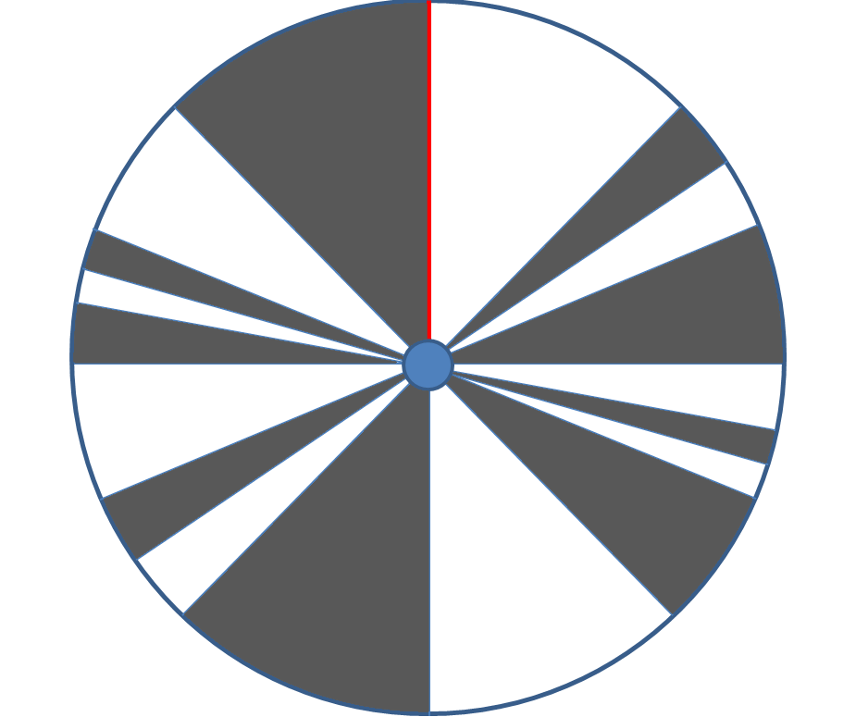

*g*

Stationary Prize Indicator

Top Prize (1°)

Figure 1: The spinning wheel of a ‘Wheel of Fortune’ game.

Q4

An unipolar stepper motor is under consideration to replace the DC motor is the application in Question 1.

* 1. Name 1 advantage of using a stepper motor over a DC motor in this application?

(2 marks)

* 1. There are two modes to drive the stepper motor: Two Phase Full Step or Two Phase Half Step. Discuss the comparative advantages of each of the driving modes.

(4 marks)

* 1. If Two Phase Half Step driving mode is used, what would be the minimum specification of the stepper motor in term of steps per revolution?

(2 marks)

* 1. If the only stepper motor available has only 50% of the required minimum stepping resolution, the technique of microstepping may be used to drive the stepper motor. Explain the working principle of microstepping.

(4 marks)

* 1. If a stepper driver is not available, we may interface the stepper motor with the MCU using 4 BUZ11 transistors as shown in Figure 3. Describe the sequence of turning the transistors ON and OFF to drive the stepper motor in both directions with using Two Phase Half Step mode. You may present your answer in a table format.

(13 marks)

Figure 3 Interfacing a stepper motor with Arduino UNO using 4 transistors.

AY21/22

Q3

A small factory’s operation involves consumption of liquid chemical in the manufacturing process. The factory has two manufacturing lines, one using a traditional process and the other is a newly added line that employs a new manufacturing process. The new line has a buffer tank to ensure a steady supply of chemical. The buffer tank is filled to its full capacity by opening the Refill Valve every hour. The factory operates around the clock in three shifts. In the current practice, the consumption of chemical is recorded manually by workers reading from the liquid level meter of the chemical storage tank around the last hour of each shift, i.e. 3 times per day.

1. The factor manager knows that the chemical consumption is low during the hour of changing shift and ramps up to the highest consumption level as the shift progresses and then tapers off towards the end of the shift. In order to study consumption pattern throughout the day, it is advised that the current 1 recording per shift would be insufficient. What is the minimum number of chemical consumption recordings per shift that you would suggest to the factor manager? Explain your answer.

(3 marks)

1. In order to compare the chemical consumption of the old versus new manufacturing lines, mass flow meters are installed at locations A and B (See Fig.2) to measure the consumption rate of each line. An Arduino UNO MCU is used to collect flow rate data measured by the two mass flow meters at a sampling rate of 1 Hz and then perform numerical integration to computer the chemical consumption.
   1. It is observed that the acquired data by the MCU fluctuates randomly throughout the measurement. It is speculated that this is due to white noise present in the measurement circuit. Is it possible for this sampling frequency to pick up white noise? Explain your answer.

(3 marks)

* 1. Suggest 1 software and 1 hardware methods to reduce the random fluctuation of the acquired data.

(4 marks)

1. This setup is sufficient to compare the chemical consumption per shift between the two manufacturing lines, but it is not able to compare the pattern of consumption throughout various process stages throughout a shift. It is decided that the mass flow meter at B is to relocate to C to allow a real-time chemical consumption comparison between the two manufacturing lines.
   1. Why is mass flow measurement at B inappropriate for real-time comparison of water consumption with the measurement at A?

(3 marks)

* 1. A differential amplifier may be used to compare the real-time difference in chemical consumption of the two manufacturing lines. Sketch a circuit diagram to illustrate a possible interfacing circuit of to implement this solution with an op-amp, frequency selective filters (e.g. low-pass, high-pass, etc.) and an Arduino UNO MCU.

(6 marks)

* 1. One equivalent software method to compare the real-time difference in chemical consumption of the two manufacturing lines is to perform frequency selective filtering and differential comparison in the firmware of the MCU. Suggest 2 advantages and 1 disadvantage of this method compared to the hardware solution implemented in Part (c-ii).

(6 marks)

Fig. 2 Factory Chemical Consumption Monitoring System

1. AY22/23

Q4

You are to design the control system of a road-railway junction, as shown in Figure 2.

Use two or more Arduino UNO MCUs to design the system with the following components:

* + Two sets of Red-Amber-Green LED Traffic Lights.
  + Four pairs of Red-Green LED Pedestrian Lights.
  + Four push buttons to activate Pedestrian Lights.
  + A wireless RF communication module that receives signal from sensors 1 km away for incoming train.
  + Four DC motors to lower & raise gantry bars
  + Two alarms to warn cars and pedestrians of incoming train.
  + Two flashing LED lights on top of the gantry pillars to warn cars and pedestrians of incoming train.
  + Two pressure sensors, one in each direction, to detect vehicles beating the red light.
  + Two cameras, one in each direction, to take picture of the rear of the vehicle which beats the red light.



Figure 2 Road-Railway Junction

Sketch a schematic block diagram to show your design of the control systems for this application. Indicate and describe clearly in your diagram all the mechatronic components (Arduino UNO MCU, sensors, actuators, I/O devices, interfacing devices, power sources, etc.) and their relationships to each other. You may make appropriate assumptions to add new components (e.g. switches, drivers, etc.), but you need to state them clearly.

Your answer needs to specify only the component type. Information on the make and model of components are not required.

(25 marks)